Sample Format Application for Artists-Download
Example
BIO:
Fatmir Tufina was born in August 1960 in the city of Tirana. His passion for painting has started since his early childhood, where sketches of conceptual variety of the painter's fantasy. In 1976 he registered in The artistic high school of Tirana. Later, he worked as a painter in the Kinostudio of Tirana in the most popular movies of the time. His creations at a young age stood out for identity and originality reflected among the colors and graphics of the world his artistic. In 1991 he moved to Düsseldorf where he joined "Düsseldorf Academy of Painters" and continued his artistic career for 5 years, and where he participated in dozens of personal exhibitions. He achieved success mainly with his style in graphics (rapid on paper, pencil on paper) where he reflects his compositions and visions on the perception of various themes. These graphics are further reflected in large-scale paintings with strong colors and conspicuous. In 1997, the painter returned home to live with his family. During this time, he has participated in various symposia art and exhibitions at home and abroad, among fellow painters. In 2019, his works were exhibited in the National Museum of Tirana. Currently he is working on new creations for a new solo exhibition as well as for other activities among other artists.
CATEGORY: ABSTRACT
STYLE: EXPRESSIONIST, ABORIGINAL, FIGURATIVE
Also a personal photo of the artist
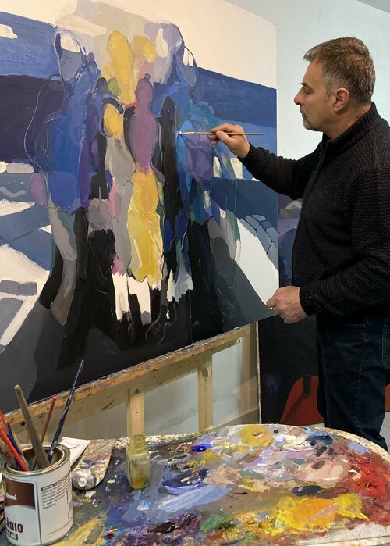

Portfolio # 1:
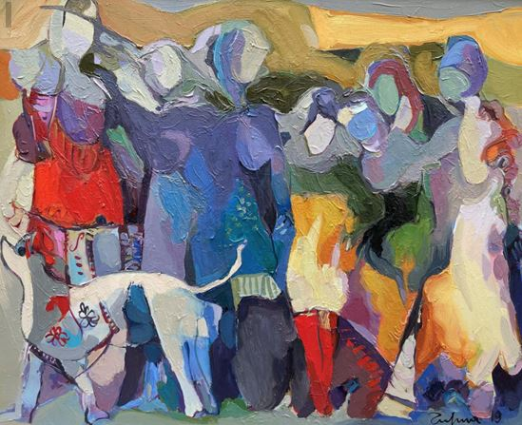

Title: Women in the city
Price: € 2,132.00
Dimensions: 80-100 cm
Year: 2019
Technique: Oil paint on canvas

Format for application of artists.
Bio:

CATEGORY:
STYLE:
PERSONAL PHOTO:

PORTFOLIO:
PICTURE:

Title:
Price:
Dimensions:
Year:
Technique:

